**Activities on Codio**

**Buffer Overflow Part I**

**Buffer Overflow in C**

To test it, enter your first name (or at least the first 8 characters of it) you should get the output which is just your name repeated back to you. **– This can be confirmed as per the screenshot below, whereby my name ‘Marianne’ is displayed correctly.**

Run the code a second time (from the command window this can be achieved by entering ./bufoverflow on the command line). This time, enter a string of 10 or more characters.

* What happens? **– The error ‘stack smashing detected’ is returned.**
* What does the output message mean? **– The output message indicates that a buffer overflow happened as the input name I entered the second time (my full forename ‘Marianne Lyne’) exceeded the buffer capacity of ten characters.**

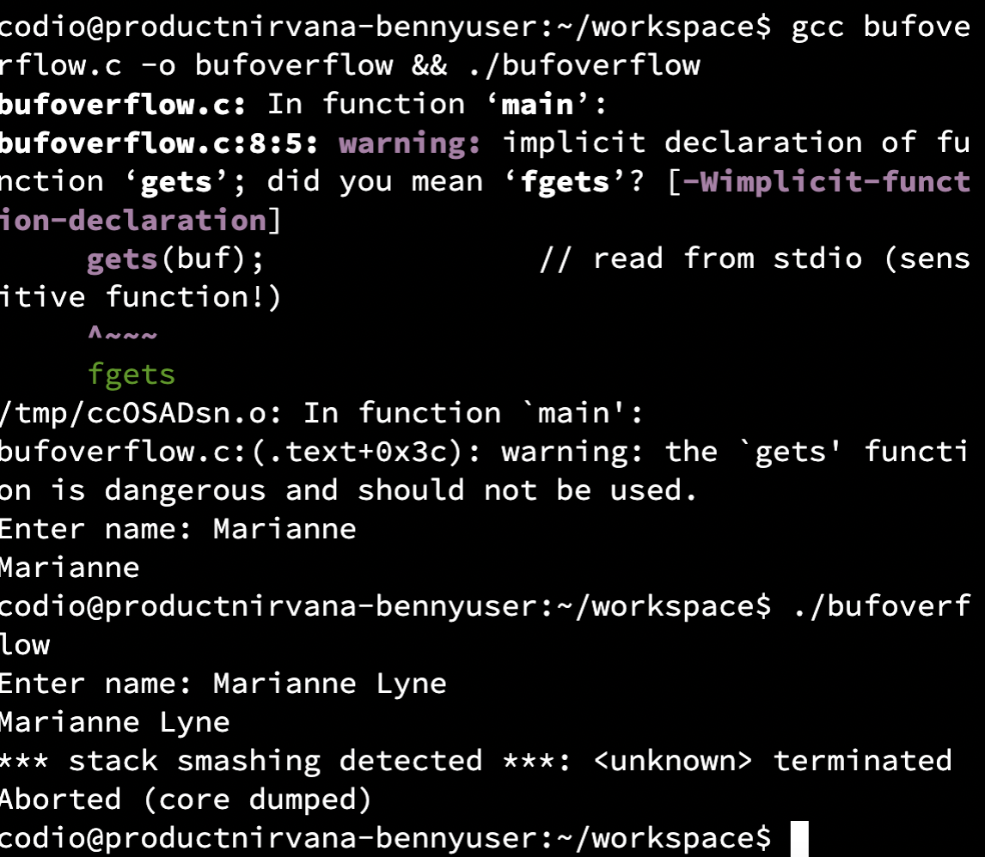

*Buffer Overflow Part II*

**Buffer Overflow in Python**

* Run the code using python overflow.py (or use the **rocket icon**)
* What is the result? **– An ‘index out of range’ (IndexError) error is returned, indicating that the index 7 for the list element does not exist.**

* Run pylint on your Overflow.py file and evaluate the output:
* What is the result? Does this tell you how to fix the error above? **- Pylint evaluates how the code could be improved/refactored by analysing it without running it, suggesting appropriate coding standards, but it does not tell how to fix the ‘IndexError’ encountered above.**

